5 Morphosis
5.1 Thom Mayne
5.2 Major projects
5.2.1 Completed
5.2.2 In progress
6. Peter Eisenman
6.1 Personal life
6.2 Education
6.3Practice
6.3.1Awards
6.3.2 Buildings and works

5. Morphosis

The Morphosis studio was founded by Thom Mayne and Michele Rotondi in Santa Monica, California, in 1975. Since 1975 the practice has been run by Mayne alone. Thom Mayne was borne in Connecticut in 1944. He received his Bachelor of Architecture degree from the University of Southern California in 1968 and his Master of Architecture from Harvard University in 1978. He was a founder of the Southern California Institute of Architecture (sci-Arc) and has held teaching positions at Columbia, Harvard (Elliot Noyes chair, 1998) and Yale Universities (Eliel Saarinen chair, 1991), the Berlage Institute in the Netherlands and the Bartlett School of Architecture in London. Currently, he holds a tenured faculty position at the ucla School of Arts and Architecture in Los Angeles. Honors received include the Prize Fellowship from the American Academy of Design in Rome (1987), elect member from the American Academy of Arts and Letters (1992), the Gold Medal of aia in Los Angeles (2000). With Morphosis, Mayne has won numerous architectural prizes, including 20 Progressive Architecture Awards and 43 aia Awards. Under his guidance, the firm has partecipated in individual and collective exhibitions in many countries around the world. Of particular note were those at the Contemporary Art Centre in Cincinnati, Ohio, the Walker Art Institute in Minneapolis, the Ministerio de Formento in Madrid, 1998, the great retrospective organized in 1999 at the Netherlands Architectural Institute (nai) and the last International Biennale of Architecture in Venice, 2002. Buildings and projects by Morphosis have been published in the leading international specialist press and in 21 monographic volumes, the most recent published by Phaidon in 2002.

5.1 Thom Mayne

Thom Mayne (b. January 19, 1944, in Waterbury, Connecticut) is a Los Angeles-based architect. Edu­cated at University of Southern California (1969)[1] and the Harvard University Graduate School of Design in 1978, Mayne helped found the Southern California Institute of Architecture (SCI-Arc) in 1972, where he is a trustee. Since then he has held teaching positions at SCI-Arc, the California State Polytechnic University, Pomona (Cal Poly Pomona) and the University of California, Los Angeles (UCLA). He is principal of Morphosis, an architec­tural firm in Santa Monica, California. Mayne recei­ved the Pritzker Architecture Prize in March 2005.

Mayne was a member of the Holcim Awards global jury in 2006 and a member of the Holcim Awards jury for region North America in 2005. He presen­ted a keynote address at the 3rd International Hol­cim Forum 2010 in Mexico City.
Mayne studied architecture at the University of Southern Cali­fornia (USC) with a social agenda and urban planning focus. After receiving his bachelor’s degree in 1968, he began working as an urban planner. During that time he recalls that »policy and planning were not going to work for me« and the he »needed a more tangible resolution.” Mayne found himself living on a commune with the grass-roots group Campaign for Economic Democracy, many of whom became his earliest clients.

In 1972, Mayne collaborated with five other students and educators whom he met at while at USC, to create the Southern California Institute of Architecture, or SCI-Arc. The goal of the institute was to reinvigorate formal architectural education with a keener sense of social conscience. SCI-Arc was «to bring to Los Angeles the critical attitude toward the profession that was being practiced at Cooper Union in New York and the Architectural Association in London.”
Morphosis

Mayne, Livio Santini, James Stafford and Michael Brickler founded Morphosis in 1972; Michael Rotondi joined in 1975. The firm's design philosophy arises from an interest in producing work with a meaning that can be understood by absorbing the culture for which it was made, and their goal was to develop an architecture that would eschew the normal bounds of traditional forms. Beginning as an infor­mal collaboration of designers that survived on non-architectural projects, its first official commission was a school in Pasadena, attended by Mayne's son. Publicity from this project led to a number of residential commissions, in­cluding the Lawrence Residence. Mayne describes the early days of the group as more of a «garage band» than a prac­tice. They spent their free time experimenting with new in­ventions for their clients, whom consisted of friends of fri­ends and parents of students.

When work was at a standstill, Mayne took a year off to earn his Master of Architecture degree from Harvard University. He graduated in 1978 and returned to work for Morphosis where he became the principal architect, lead designer and principal in charge for all of Morphosis’ projects. The firm has grown into prominent design practice, with completed projects worldwide. Under the Design Excellence program of the United States government's General Service Administra­tion, Thom Mayne has become a primary architect for federal projects. Recent commissions include: graduate housing at the University of Toronto; the San Francisco Federal Building; the University of Cincinnati Student Recreation Cen­ter; the Science Center School in Los Angeles, Diamond Ranch High School in Pomona, California; and the Wayne L. Morse United States Courthouse in Eugene, Oregon.

The work of Morphosis has a layered quality. Visually, the firm’s architecture includes sculptural forms. In recent years, such visual effect has been made possible increasin­gly through computer design techniques, which simplify the construction of complex forms.
Academics

Mayne remains a presence in the academic world. He has held teaching positions at many institutions including Columbia University, Harvard University, Yale University, the Berlage Institute in the Netherlands and the Bartlett School of Architecture in London. Currently, he is a tenured faculty member at the UCLA School of Arts and Architecture.

5.2 Major projects

5.2.1 Completed
New Academic Building at 41 Cooper Square, The Cooper Union for the Advancement of Science and Art, New York, New York, 2009
National Oceanic Atmospheric Administration (NOAA) Satellite Operation Facility, Suitland, Maryland, 2007
Cahill Center for Astronomy and Astrophysics at the California Institute of Technology, Pasadena, California, 2009
San Francisco Federal Building, San Francisco, California, 2006
Wayne L. Morse United States Courthouse, Eugene, Oregon, 2006
Public housing in Madrid], Spain, 2006[9]
University of Cincinnati Student Recreation Center, Cincinnati, Ohio, 2006
Science Center School, Los Angeles, California, 2004
Caltrans District 7 Headquarters, Los Angeles, California, 2004
Hypo Alpe-Adria Center, Klagenfurt, Austria, 2002
University of Toronto Graduate House, Toronto, Ontario, Canada, 2000
Diamond Ranch High School, Pomona, California, 1999
Sun Tower in Seoul, Korea 1997
Blades Residence, Santa Barbara, California, 1995
Salick Healthcare Office Building, Los Angeles, CA, 1991
Crawford Residence, Montecito, CA, 1990
Cedar Sinai Comprehensive Cancer Center, Los Angeles, CA, 1988
6th Street Residence, Santa Monica, CA, 1988
Kate Mantilini / Beverly Hills, CA, 1986

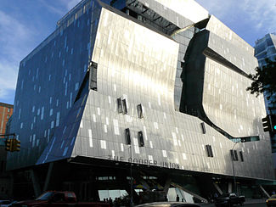  Mayne's New Academic Building for Cooper Union (2009) | 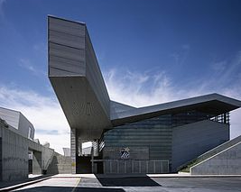  Diamond Ranch High School  (1999) Pomona, California, United States  Possibly the most fun high school in the entire United States, Diamond Ranch High School emerges from its landscape in a series of folding angular planes that create a memorable open courtyard and a campus that somehow feels as if its just in the right place.
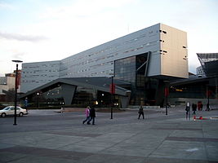  University of Cincinnati Rec Center (2006) | 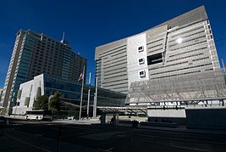  San Francisco Federal Building (2006)

5.2.2 In progress
Phare Tower (Tour Phare), also known as «Le Phare» and «The Lighthouse», «green» wind-powered office building, La Défense, Paris, France, 2012
Perot Museum of Nature & Science, Victory Park, Dallas, Texas, 2013
Vialia Vigo, Vigo, Galicia, Spain, 2016
Emerson College Los Angeles Center, Los Angeles, California, 2014[10]
Cornell NYC Tech campus, Roosevelt Island, New York, 2017

6. Peter Eisenman

6.1 Personal life

Peter Eisenman (born August 11, 1932 in Newark, New Jersey) is an American architect. Eisenman's professional work is often referred to as formalist, deconstructive, late avant-garde, late or high modernist, etc. A certain fragmenting of forms visible in some of Eisenman's projects has been identified as characteristic of an eclectic group of architects that were (self-)labeled as deconstructivists, and who were featured in an exhibition by the same name at the Museum of Modern Art. The heading also refers to the storied relationship and collaborations between Peter Eisenman and post-structuralist thinker Jacques Derrida.

Peter Eisenman's writings have pursued topics including comparative formal analyses; the emancipation and autonomization of the discipline; and histories of Architects including: Giuseppe Terragni, Andrea Palladio, Le Corbusier and James Stirling. While he has been referred to as a polarizing figure[citation needed], such antagonistic associations are likely prompted by Colin Rowe's 1972 criticism that the work pursues physique form of European modernism rather than the utopian social agendas (See "Five Architects," (New York: Wittenborn, 1972)) or more recent accusations that Eisenman's work is "post-humanist" (Perhaps because his references to the Renaissance are 'merely' formal). While his apathy towards the recent "green" movement is considered polarizing or "out-of-touch", this architect-artist (with drawings held by major collections) was also an early advocate of computer aided design. Eisenman employed fledgling innovators such as Greg Lynn and Ingeborg Rocker as early as the 1989.[citation needed] Despite these claims of polarity and autonomization, Eisenman has famously pursued dialogues with important cultural figures internationally. These include his English mentor Colin Rowe, the Italian historian Manfredo Tafuri, George Baird, Fredric Jameson,[citation needed] Laurie Olin, Rosalind Krauss and Jacques Derrida. In addition to his vast literary contributions (as editor, curator, and writer) and professional practice, Eisenman's reputation as a critic and professor of architecture is similarly famed.

6.2 Education

As a child Eisenman attended Columbia High School located in Maplewood, New Jersey. He discovered architecture as an undergraduate at Cornell University and gave up his position on the swimming team in order to immerse himself in the architecture program there. Eisenman received a Bachelor of Architecture Degree from Cornell, a Master of Architecture Degree from Columbia University's Graduate School of Architecture, Planning and Preservation, and M.A. and Ph.D. degrees from the University of Cambridge. He received an honorary degree from Syracuse University School of Architecture in 2007.

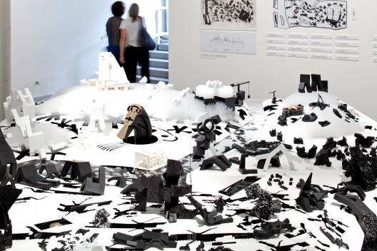

Field of Dreams. Ohio State University Knowlton School of Architecture

Eisenman currently teaches theory seminars and advanced design studios at the Yale School of Architecture.[4] He is Professor Emeritus at the Cooper Union School of Architecture.[5] Eisenman formerly taught at Cambridge University, Harvard University, the University of Pennsylvania, Princeton University, and the Ohio State University.

6.3 Practice

Eisenman first rose to prominence as a member of the New York Five (also known as the Whites, as opposed to the Grays of Yale: Bob Stern, Charles Moore, etc.), five architects (Eisenman, Charles Gwathmey, John Hejduk, Richard Meier, and Michael Graves) some of whose work was presented at a CASE Studies conference in 1967. Eisenman received a number of grants from the Graham Foundation for work done in this period. These architects' work at the time was often considered a reworking of the ideas of Le Corbusier. Subsequently, the five architects each developed unique styles and ideologies, with Eisenman becoming more affiliated with the Deconstructivist movement.

Eisenman's focus on "liberating" architectural form was notable from an academic and theoretical standpoint but resulted in structures that were both badly built and hostile to users. The Wexner Center, hotly anticipated as the first major public deconstructivist building, has required extensive and expensive retrofitting because of elementary design flaws (such as incompetent material specifications, and fine art exhibition space exposed to direct sunlight). It was frequently repeated that the Wexner's colliding planes tended to make its users disoriented to the point of physical nausea; in 1997 researcher Michael Pollan tracked the source of this rumor back to Eisenman himself. In the words of Andrew Ballantyne, "By some scale of values he was actually enhancing the reputation of his building by letting it be known that it was hostile to humanity."

Eisenman's House VI, designed for clients Richard and Suzanne Frank in the mid 1970's, confounds expectations of structure and function. Suzanne Frank was initially sympathetic and patient with Eisenman's theories and demands. But after years of fixes to the badly specified and misbegotten House VI (which had first broken the Franks' budget then consumed their life savings), Suzanne Frank was prompted to strike back with Peter Eisenman's House VI: The Client's Response, in which she admitted both the problems of the building, as much as its virtues.

Eisenman has also embarked on a larger series of building projects in his career, including the recently completed Memorial to the Murdered Jews of Europe in Berlin and the new University of Phoenix Stadium in Glendale, Arizona. His largest project to date is the soon-to-be completed City of Culture of Galicia in Santiago de Compostela, Spain.

Eisenman is featured in wide print and many films, including the 30 minute 2008 film Peter Eisenman: University of Phoenix Stadium for the Arizona Cardinals where he provides a tour of his recent construction.
6.3.1 Awards

In 2001, Eisenman won the National Design Award for Architecture from the Cooper-Hewitt National Design Museum.

6.3.2 Buildings and works

The City of Culture in Galicia
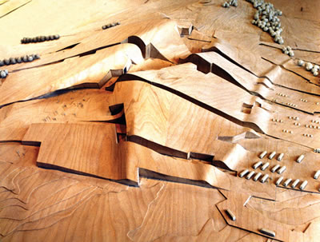 | 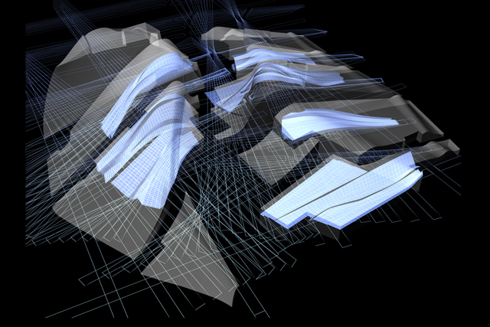
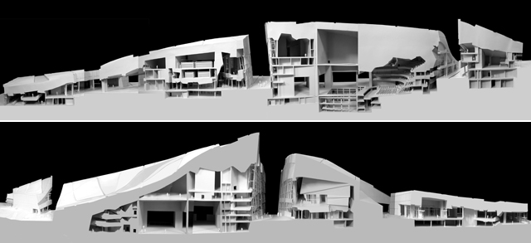

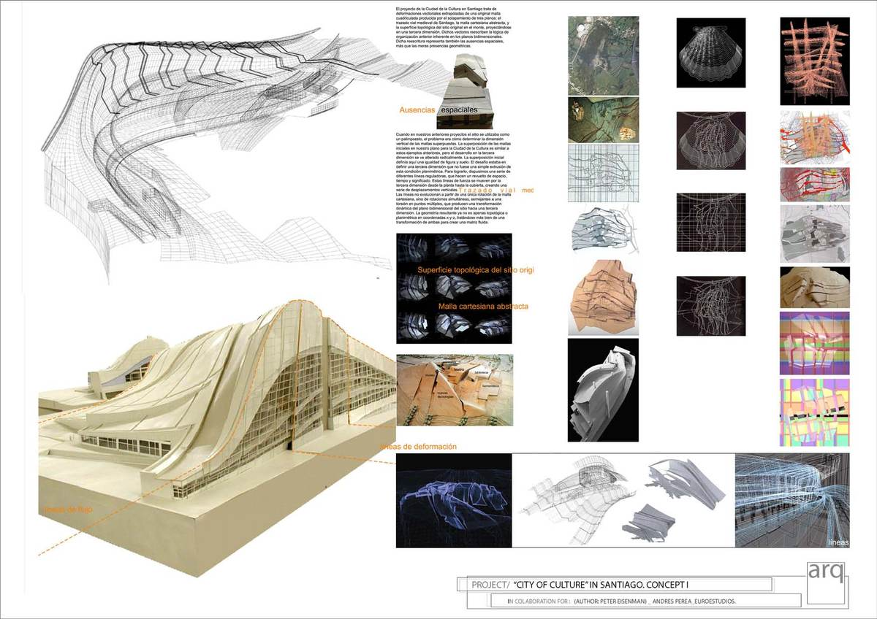
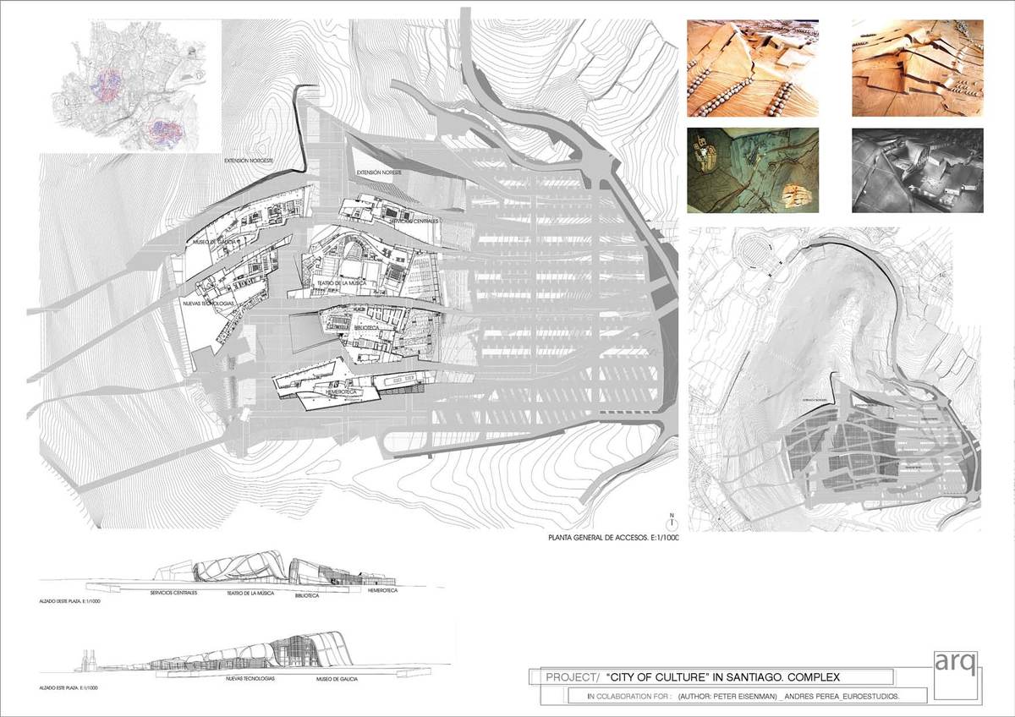
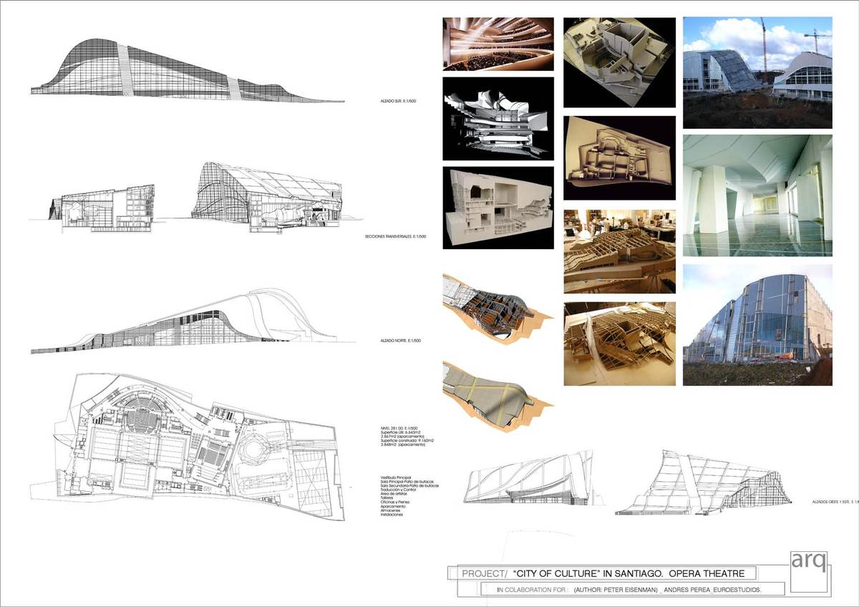

USGS satellite image of the Greater Columbus Convention Center.
Falk House (House II Eisenman), Hardwick, Vermont, 1969
House VI (Frank residence), Cornwall, Connecticut, Design: 1972.
Wexner Center for the Arts, Ohio State University, Columbus, Ohio, 1989
Nunotani building, Edogawa Tokyo Japan, 1991
Greater Columbus Convention Center, Columbus, Ohio, 1993
Aronoff Center for Design and Art, University of Cincinnati, Cincinnati, Ohio, 1996
City of Culture of Galicia, Santiago de Compostela, Galicia, Spain, 1999
Il giardino dei passi perduti, Castelvecchio Museum, Verona, 2004
Memorial to the Murdered Jews of Europe, Berlin, 2005
University of Phoenix Stadium, Glendale, Arizona, 2006

